**DAILY ONLINE ACTIVITIES SUMMARY**

|  |  |  |  |  |  |  |  |  |
| --- | --- | --- | --- | --- | --- | --- | --- | --- |
| **Date:** | **25-05-2020** | | | | | **Name:** | **kavya** | |
| **Sem & Sec** | **6th & A** | | | | | **USN:** | **4AL17CS041** | |
| **Online Test Summary** | | | | | | | | |
| **Subject** | | **-** | | | | | | |
| **Max. Marks** | | **-** | | **Score** | | | **-** | |
| **Certification Course Summary** | | | | | | | | |
| **Course** | **Python course for Machine Learning** | | | | | | | |
| **Certificate Provider** | | | **GreatLearning** | | **Duration** | | | **5hours** |
| **Coding Challenges** | | | | | | | | |
| **Problem Statement:-** | | | | | | | | |
| **Status:0 programs were given** | | | | | | | | |
| **Uploaded the report in Github** | | | | | **yes** | | | |
| **If yes Repository name** | | | | | [**https://github.com/kavya-077/DAILY-STATUS**](https://github.com/kavya-077/DAILY-STATUS) | | | |
| **Uploaded the report in slack** | | | | | **yes** | | | |

Online Test Details: (Attach the snapshot and briefly write the report for the same)

Certification Course Details: (Attach the snapshot and briefly write the report for the same)

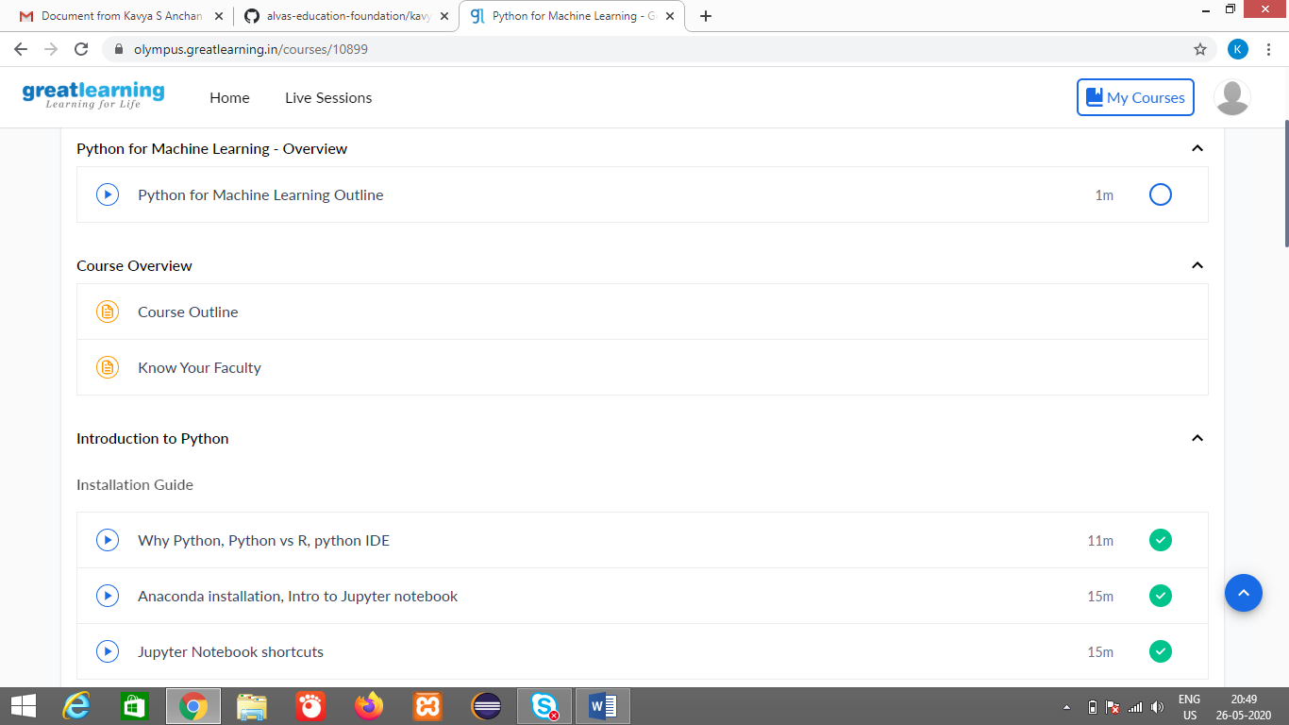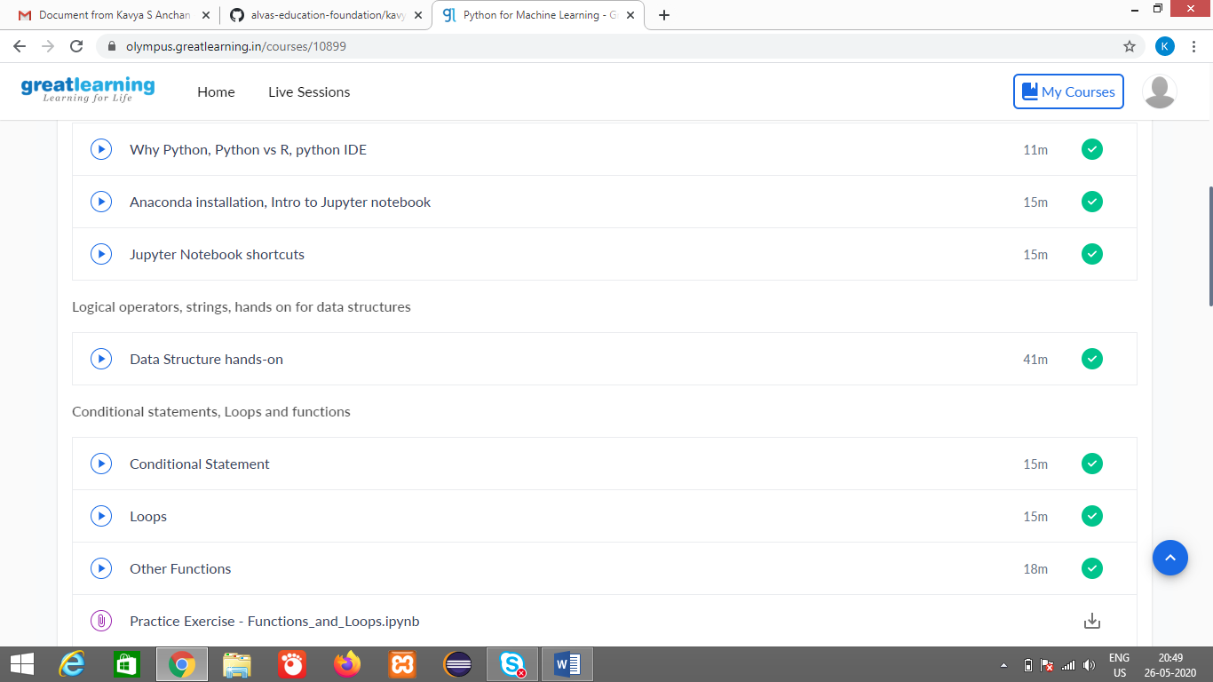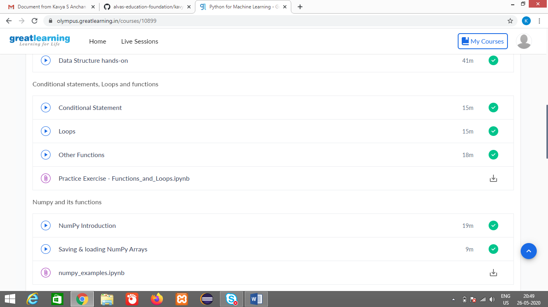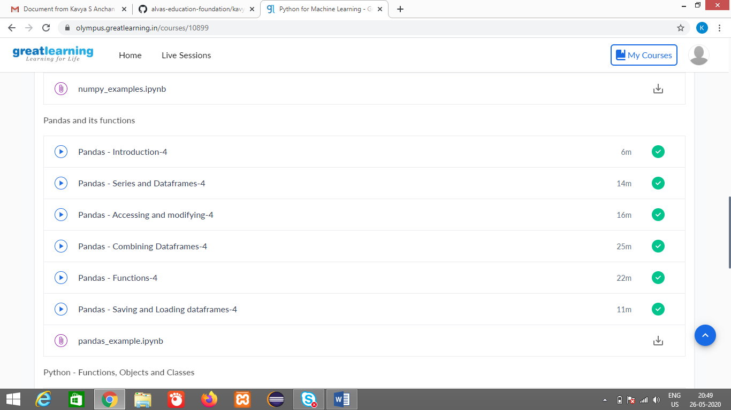

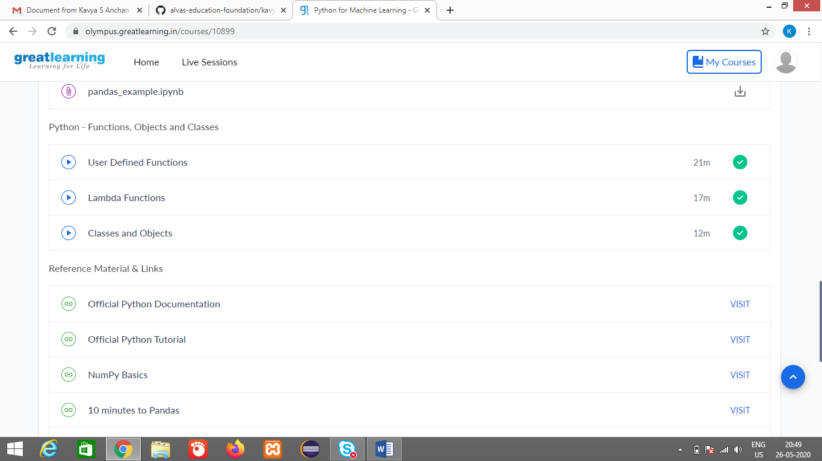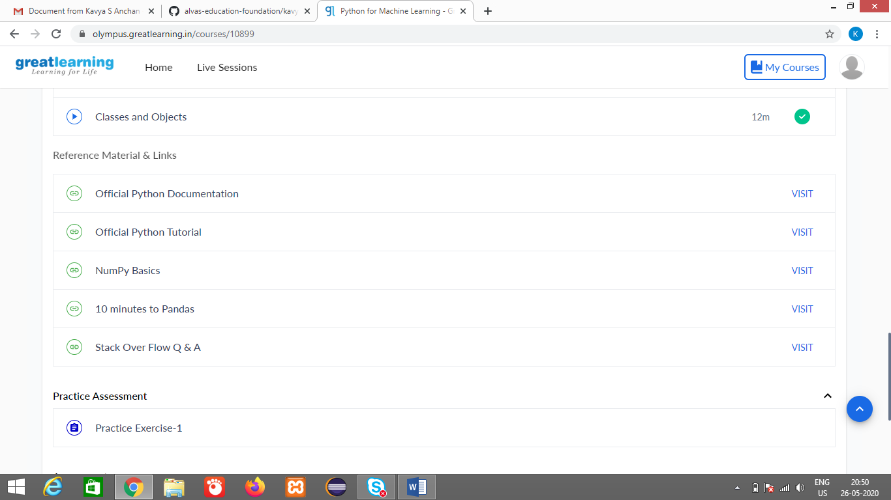

Coding Challenges Details: (Attach the snapshot and briefly write the report for the same)